# Qualitative Loop Analysis Notes

2/11/2016

Met with Chris Harvey about QLA he has done

Walked through California Current work and the process

He passed along a bunch of papers, including one by Melbourne-Thomas (Antarctic stuff) that comes with code (probably similar to the M-T 2013 I had found already). Also, Jon Reum has done some work on shellfish in PS and could be a good resource.

Make sure self-limiting links are on each node.

Make sure correct arrows and dots are used in Dia

4/9/2016

Built model *SS.dia*, using input from Correigh and oceanographers.

Model seems to run okay in R.

For Salish Sea Conference, prepared 3 different scenarios to look at impacts:

1. Foodweb
2. Anthropogenic
3. Combined

CG asked for revisions to model and to build out additional scenarios. New model is *SSv2*.dia.

Scenarios:

1. Foodweb
2. Human Impacts
3. Climate Change
4. Combined

Model was not behaving as expected with foodweb and combined impacts. Number of accepted model runs for the perturbations were very low for those scenarios.

All output was captured in file: *Salish Sea Conference Pres April 2016 v2*

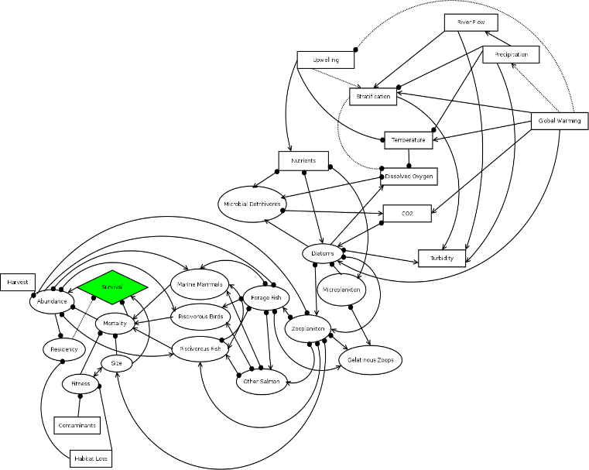

SS.dia

4/21/16

Rebuilt model (SSv4.dia).

This model was built after CG scrutinized the previous model:

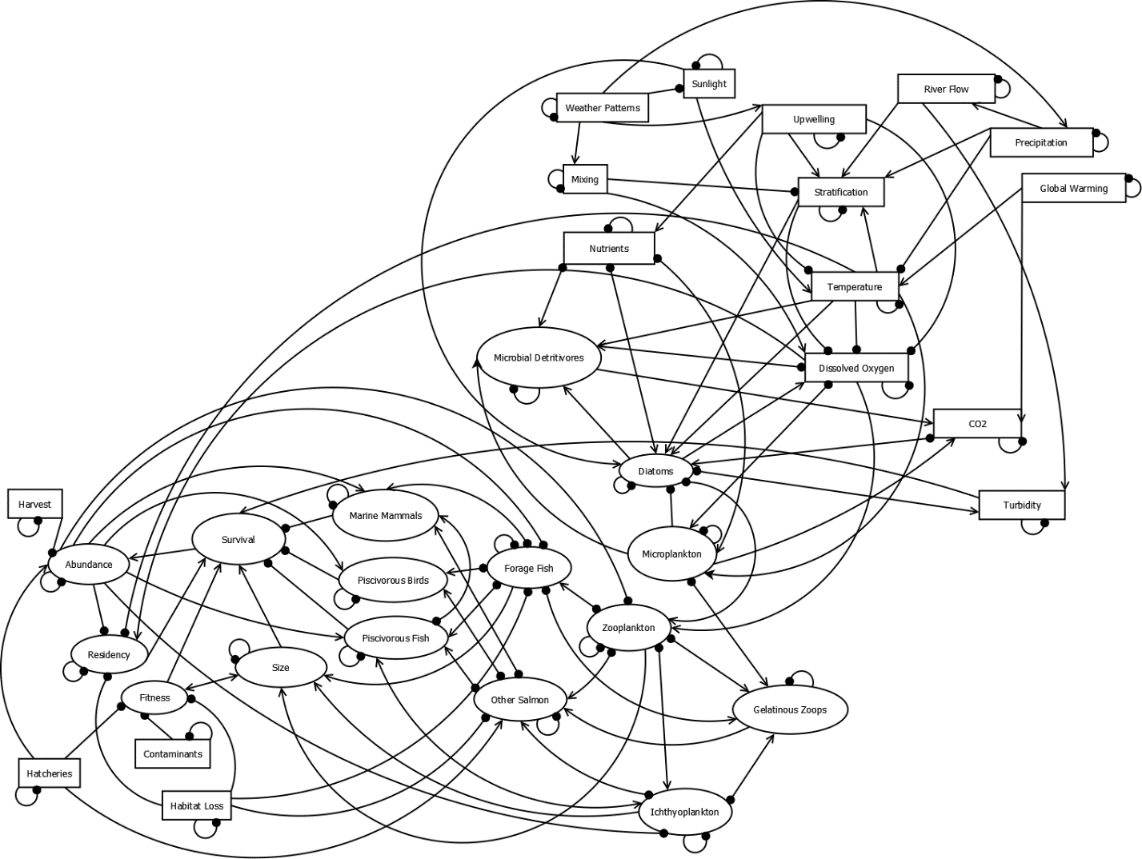

SSv4.dia

SSv4 was much more complex in the oceanography section.

Additionally, mortality, which served as a mediating box for predation mortality, was also removed, leaving just survival and abundance. Some changes to the connections from mortality were made to the two remaining boxes.

There are still some uncertainties in this version of the model. E.g., turbidy positively effects survival. Michael Schmidt also questioned this connection—since it really isn’t direct. But CG felt it should remain because of the “predation shielding” that high turbidity provides (some evidence from CR plume, although same behavior in Puget Sound has not been documented). Produced a second version of this model (SSv5.dia) with this linkage removed. Behavior is similar—although there are changes to turbidity impacts.

4/28/2016

Using code from Ben Raymond (email April 25, 2016), modified output form impact.action.barplot to iterate output plots for each perturbation.

Generated a vector of press perturbations (*Press Perturbations.xlsx*) that were used in code to modify each node in the logical direction.

|  |  |
| --- | --- |
| **Node** | **Press** |
| Abundance | -1 |
| CO2 | 1 |
| Contaminants | 1 |
| Diatoms | -1 |
| Dissolved Oxygen | -1 |
| Fitness | -1 |
| Forage Fish | -1 |
| Gelatinous Zoops | 1 |
| Global Warming | 1 |
| Habitat Loss | 1 |
| Harvest | 1 |
| Hatcheries | 1 |
| Ichthyoplankton | -1 |
| Marine Mammals | 1 |
| Microbial Detritivores | 1 |
| Microplankton | 1 |
| Mixing | -1 |
| Nutrients | 1 |
| Other Salmon | 1 |
| Piscivorous Birds | 1 |
| Piscivorous Fish | -1 |
| Precipitation | 1 |
| Residency | -1 |
| River Flow | 1 |
| Size | -1 |
| Stratification | 1 |
| Sunlight | 1 |
| Survival | -1 |
| Temperature | 1 |
| Turbidity | -1 |
| Upwelling | -1 |
| Weather Patterns | 1 |
| Zooplankton | -1 |

This was input to the code and was used to create a matrix of perturbations (-1,1 for the node of choice, 0s for all other).

Output of this iterative perturbations is *Indiv_Perturb_v4.pdf.*

By comparing impacts of each node, can get idea of strong influencers.

To simplify this plot to show just designated nodes (e.g. Survival, Abundance, and Other Salmon), generated modified plotting code function called myplot. This is modified from the QPress:::impact.action.barplot function. Ben Raymond had written it with a toshow argument to the function, but I could not get that to work as seamlessly with 33 boxes as with his 3 box example, so I wrote it a little differently, hard-coding in the select nodes:

myplot <- function(nodes,As,perturb,monitor,epsilon=1.0E-5,main="",cex.axis=1) {

pal <- c("firebrick1", "#808080", "lightblue")

results <- matrix(0,length(nodes),3)

for(i in 1:length(As)) {

impact <- signum(drop(As[[i]]%*%perturb),epsilon=epsilon)

if(all(monitor==impact,na.rm=T)) {

results <- results + outer(impact,-1:1,'==')

}

}

rownames(results) <- nodes

nodes <- nodes[c(19, 1, 28)]

results <- results[c(19, 1, 28),]

lwidth <- max(strwidth(nodes,units="inches",cex=cex.axis))

opar <- par(mai=c(1,lwidth+0.2,0.4,0.4)+0.2)

barplot(t(results),horiz=T,las=1,border=F,col=pal,

xlab="Simulations",main=main,cex.axis=cex.axis)

par(opar)

}

5/10/2016

Gave presentation to SSMSP technical team on 5/4. Presented model SSv4 and outputs. Notes on model in notebook—mainly add disease.

SSv4 is much more complex in the oceanography section—but may be overly complex.

Isaac Kaplan said QNA is essential tool—should work through it more. Especially interested in single perturbations and outcomes for the model nodes of interest.

5/13/2016

After meeting, updated model to include disease and take out mixing—simplify oceanography.

Met with Correigh and Michael on 5/12—want to run a few scenarios representative of situations in South Sound, Hood Canal, and a general central/Whidbey basin scenario. Can compare.

Output May 18, 2016

(Sent to Isaac Kaplan for feedback)

Conceptual directed diagram (digraph) of the Salish Sea in relation to survival of salmon (taken here to be Chinook, Coho, Steelhead). Model compartments (ovals or rectangles) represent biomass pools, ecosystem drivers, and traits of interest. Lines with arrows show positive relationships; lines with filled circles show negative relationships. Small negative loops on model compartments represent self-limiting functions.

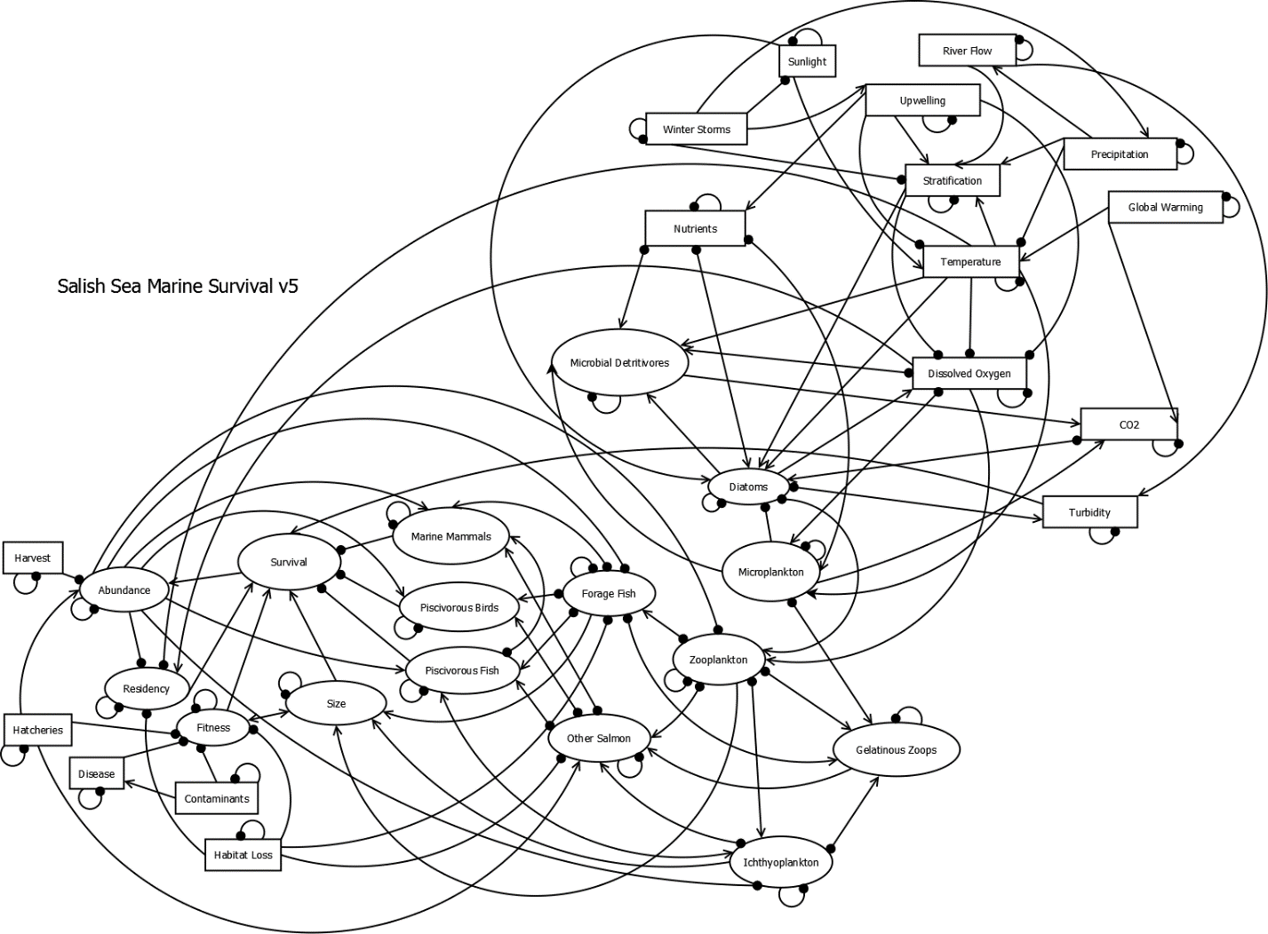

This version of the model is different from previous versions in that:

-It has a disease node

-The mixing node has been removed

-The bi-directional arrow has been restored between Fitness and Size

Scenarios for Basin-Level Effects

|  |  |  |  |  |  |
| --- | --- | --- | --- | --- | --- |
| **South Sound** | Perturbation | **Hood Canal** | Perturbation | **General Basin** | Perturbation |
| Temperature | ↑ | Stratification | ↑ | Temperature | ↑ |
| Gel. Zooplank. | ↑ | Dissolved Oxygen | ↑ | Diatoms | ↓ |
| Nutrients | ↑ | Turbidity | ↑ | Gel. Zooplank. | ↑ |
| Forage Fish | ↓ |  |  | Forage Fish | ↓ |
| Habitat Loss | ↑ |  |  | Marine Mammals | ↑ |
| Contaminants | ↑ |  |  | Habitat Loss | ↑ |
| Hatcheries | ↑ |  |  | Contaminants | ↑ |
|  |  |  |  | Hatcheries | ↑ |

Output for Scenarios:

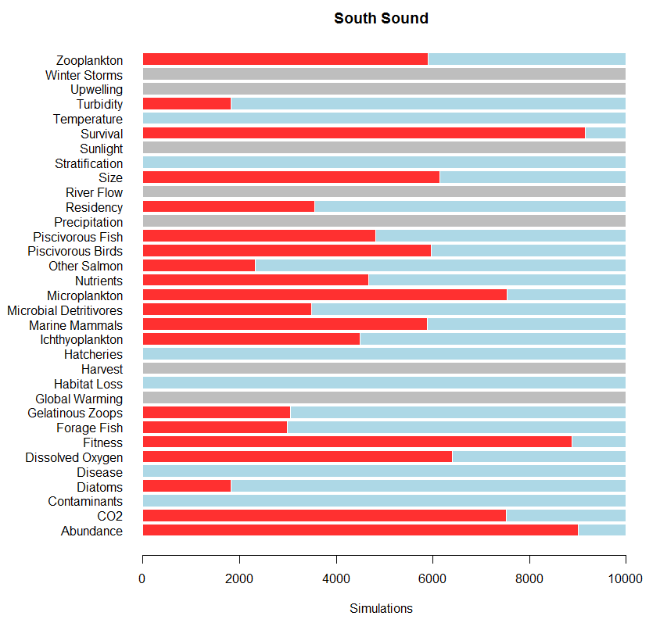

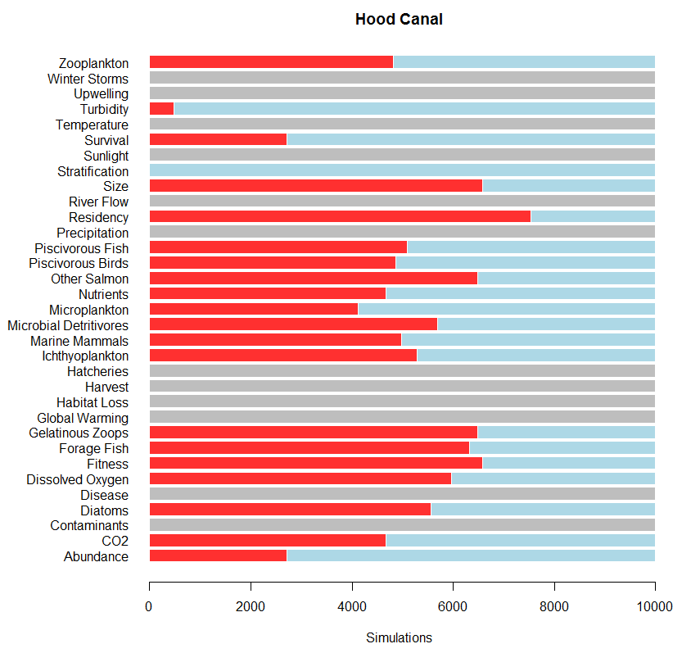

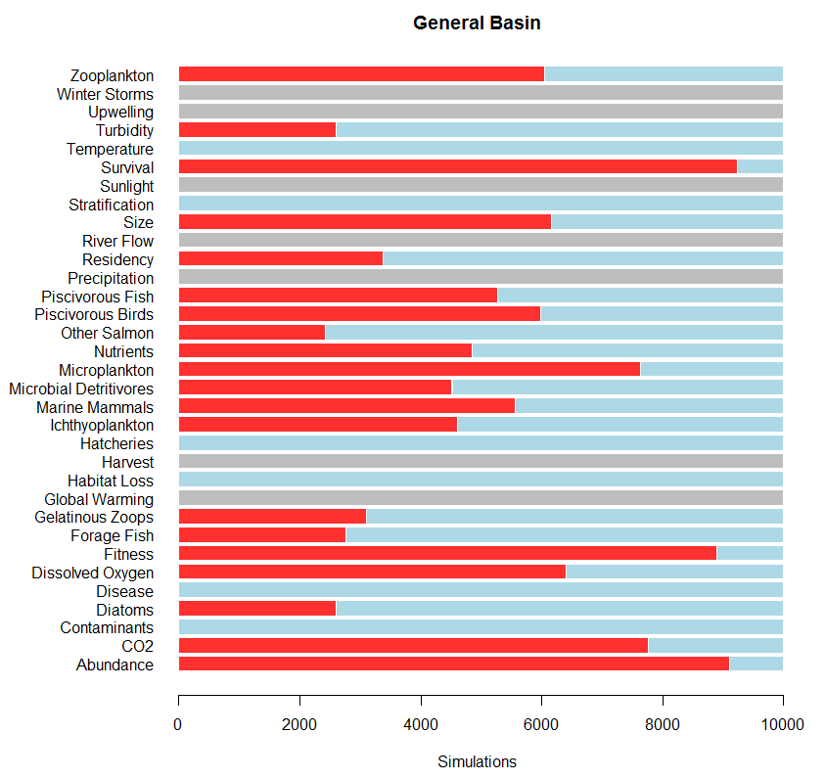

Summary of Scenarios:

* Survival is lowest (most negative in General Basin and South Sound Scenarios), much higher in Hood Canal. This seems to reproduce the actual trends.
* Other Salmon do well in SS and GB, but not as well in HC, where about 60% of the models show a negative response.
* Residency response is mostly negative in Hood Canal, but positive in the other two scenarios.
* Fitness is negative in GB and SS scenarios.

Outputs for single perturbations for 6 selected nodes:

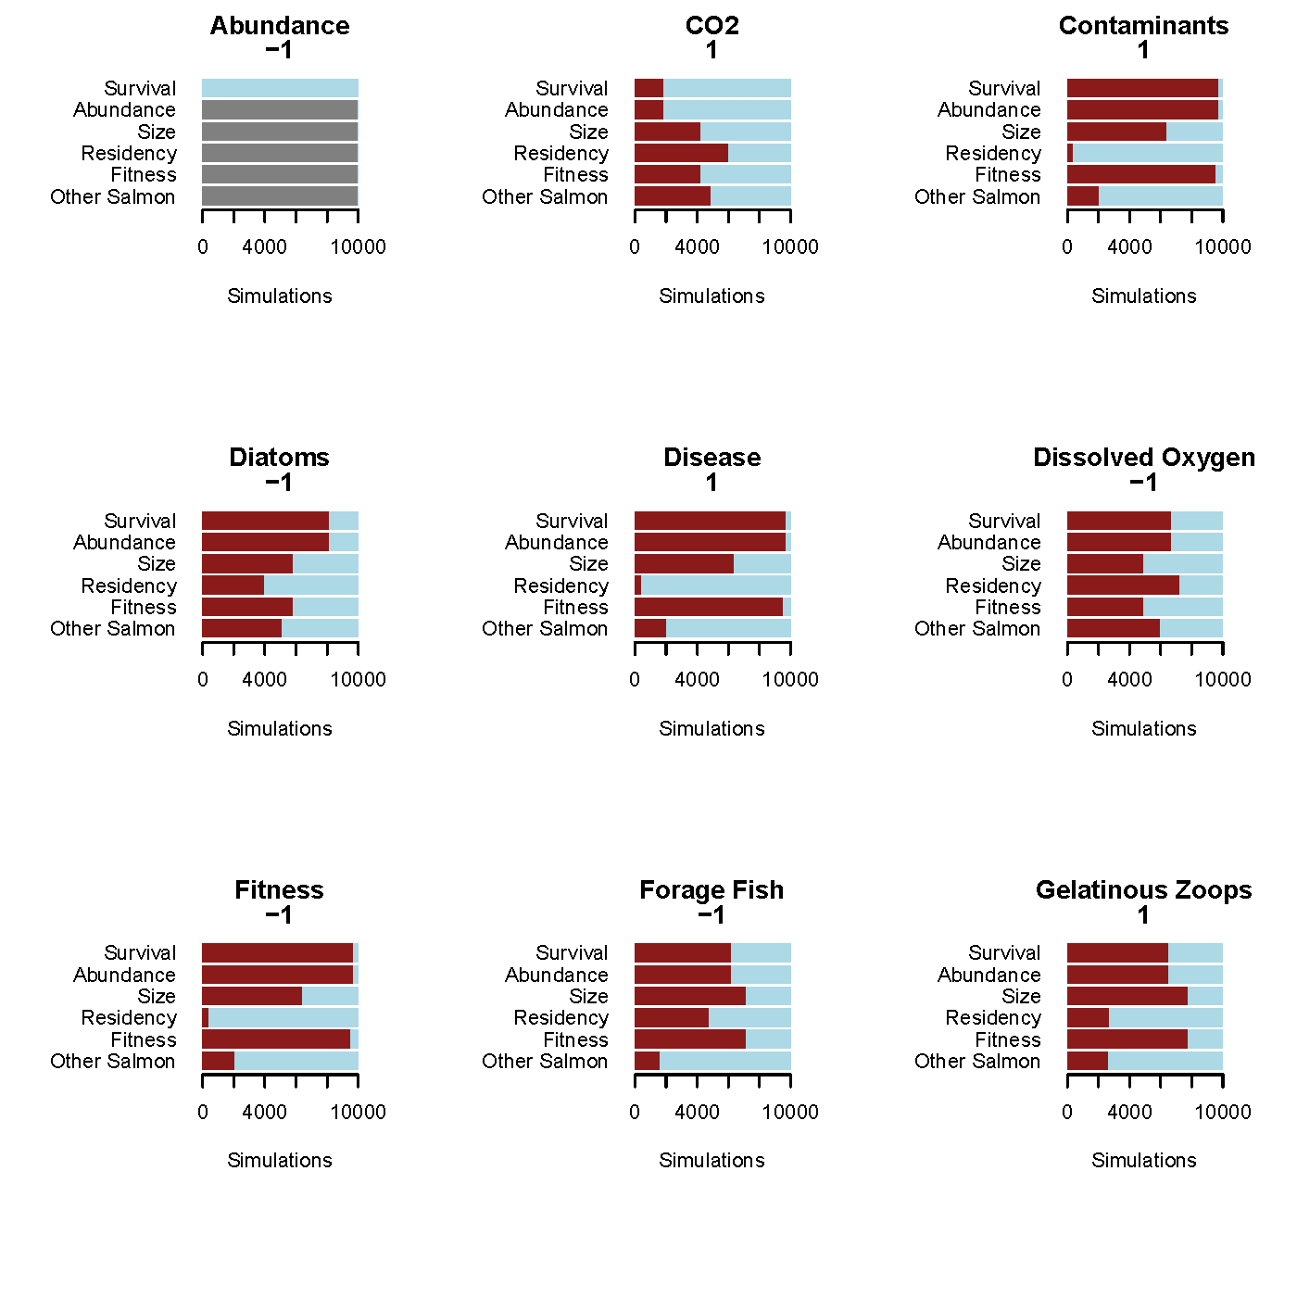

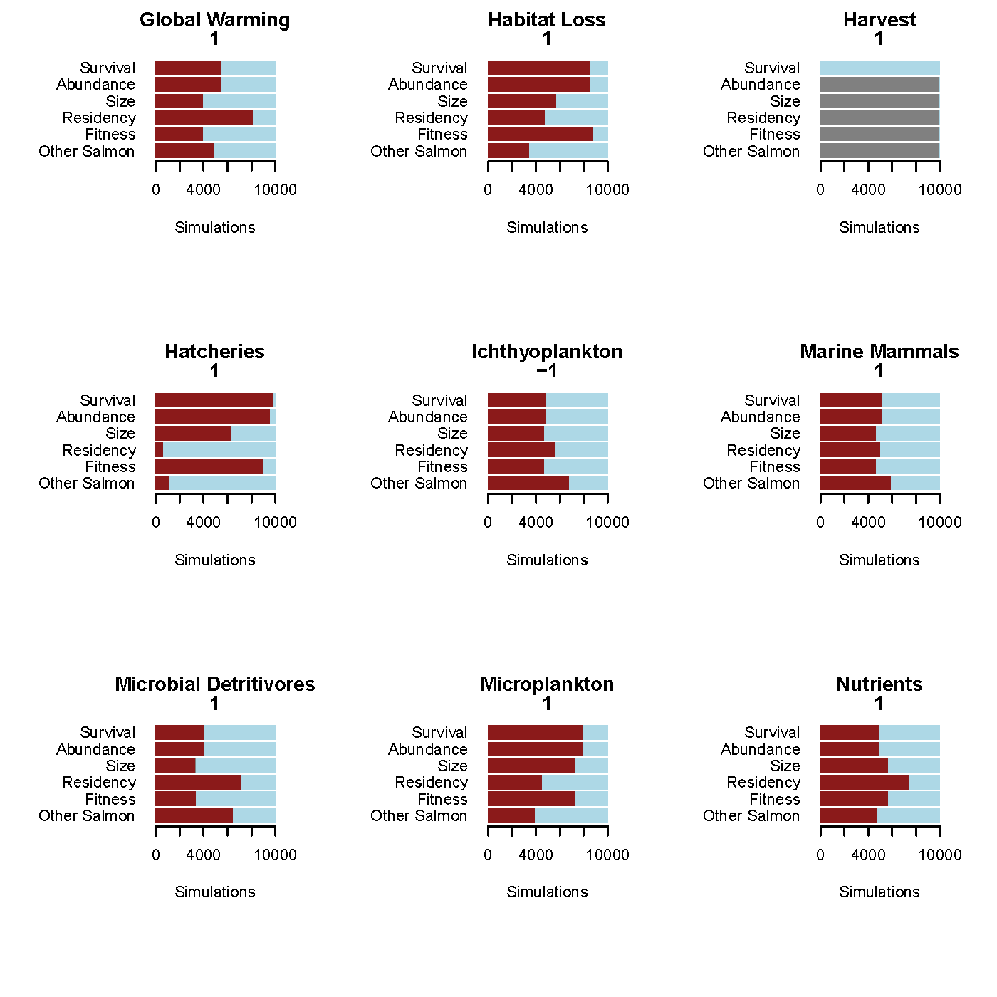

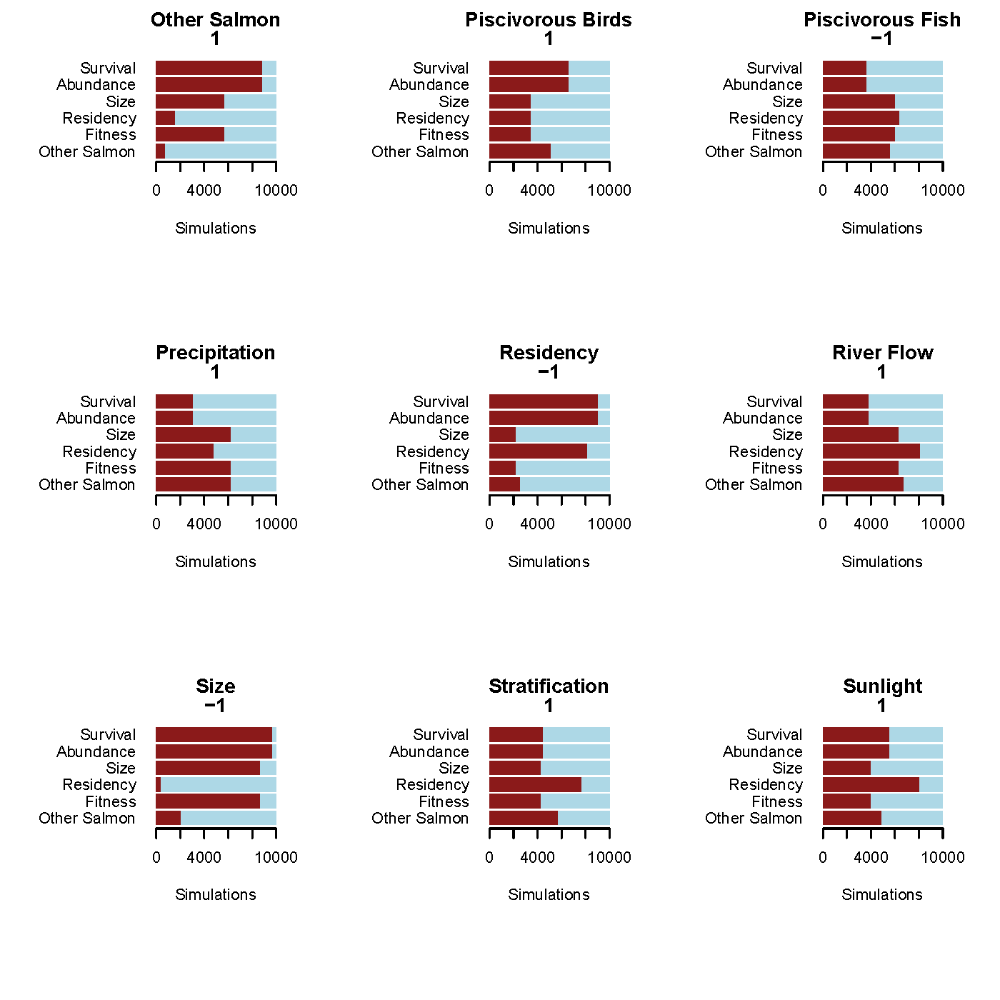

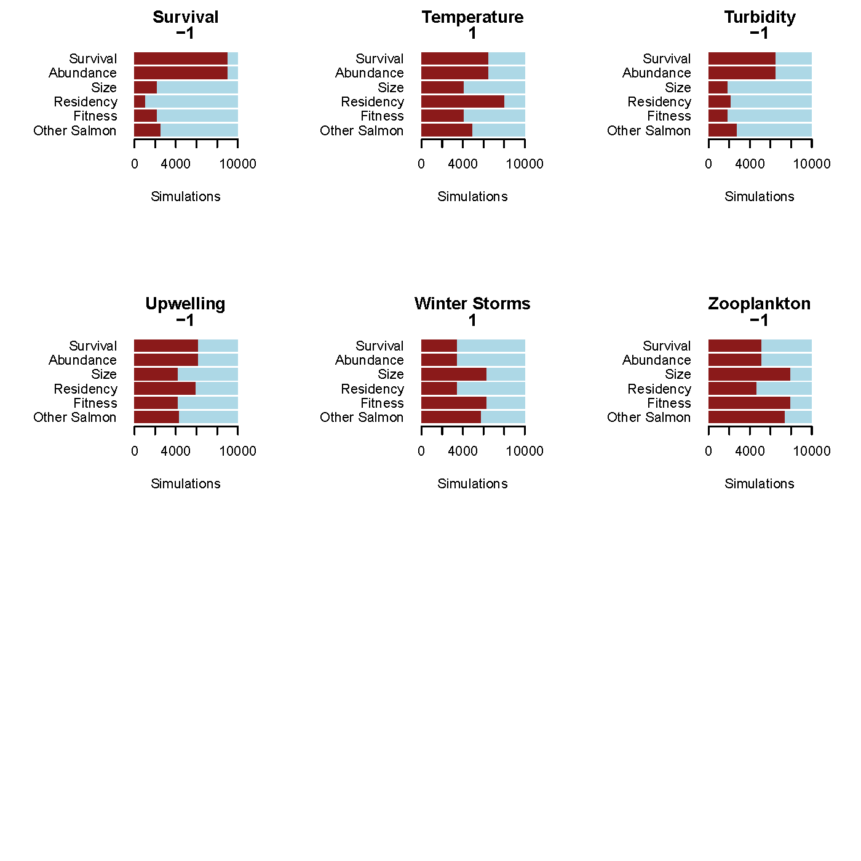

Summary Indiv. Perturbations:

* A decline in some meso-level foodweb components (zooplankton, forage fish) have across the board moderate to strong effects.
* Low-trophic level nodes also have strong negative effects (microzooplankton, diatoms, gelatinous zoops.).
* Direct effects (habitat loss, contaminants, disease) have strong negative responses, but some oceanography components—which are further removed from the nodes of interest—also have strong negative responses (dissolved oxygen, nutrients, temperature)
* Puzzling that the abundance/survival and harvest/survival interactions are contrary to hypotheses, but it likely has to do with feedback loops

5/18/2016

Next Steps:

Investigate network properties—explored R a bit to see if any of the network packages would read Dia files—coming up blank. Would be nice to find a way to use these packages, but may have to write some translational code to do so—will need to see how much use we think it will be.

Scenarios? Where to go with those? Should we monitor some of the boxes to see how realistic the models are?

6/28/2016

Revised v6 model so that it was neatened up and more readable…not much improvement. Used SSv6Neat as the working model, then saved it as SSv7. Ran in R and seemed to work. This is the current operating model.

**SSv7.dia**

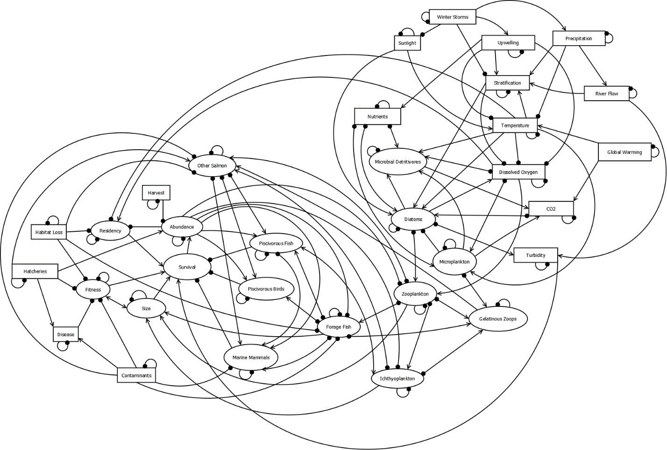

**SSv7.dia**

Made one slight change—removed direct connection between disease and hatcheries—goes through fitness only now

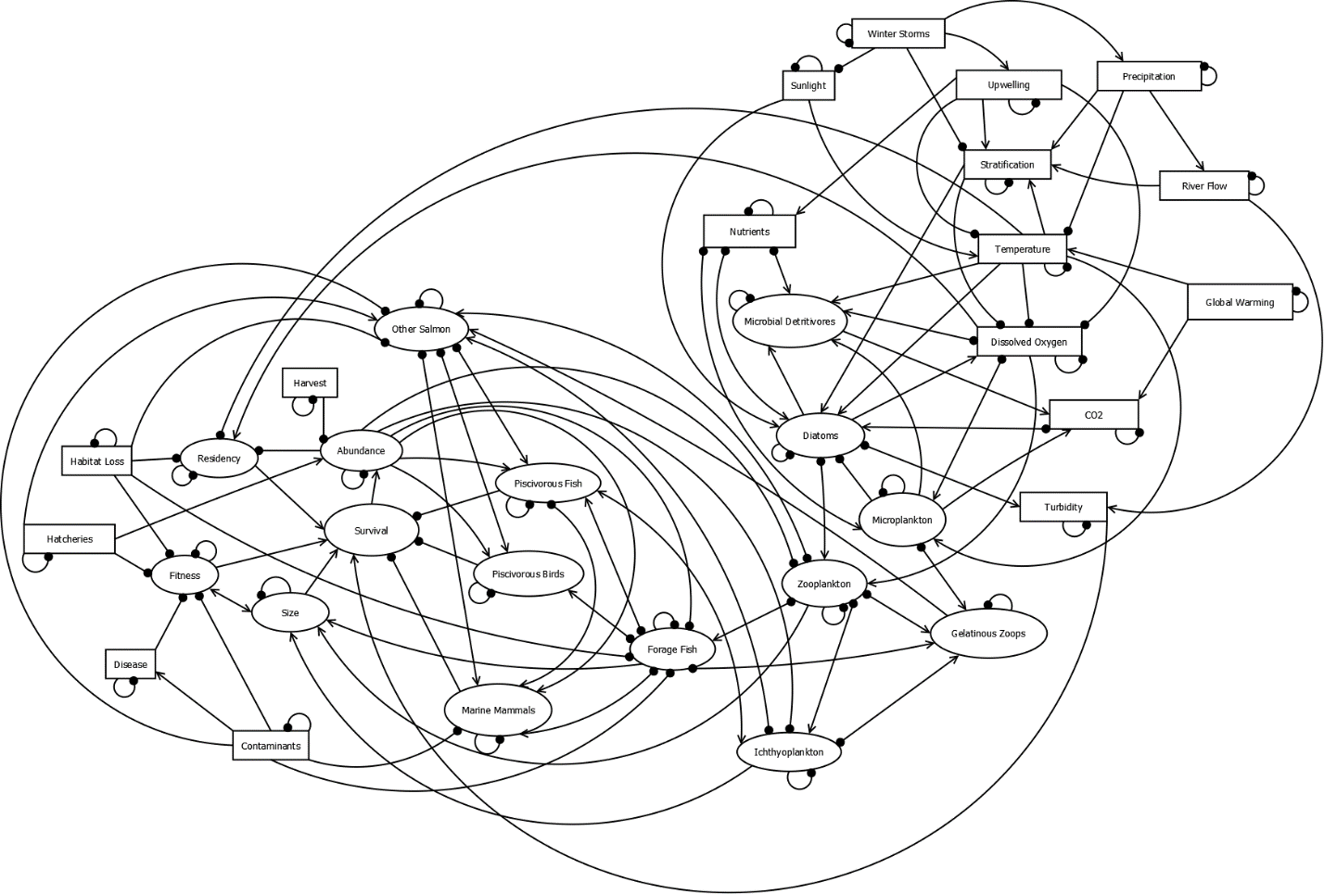

Re-ran single node perturbation (direction of perturbation invoked is in parentheses):

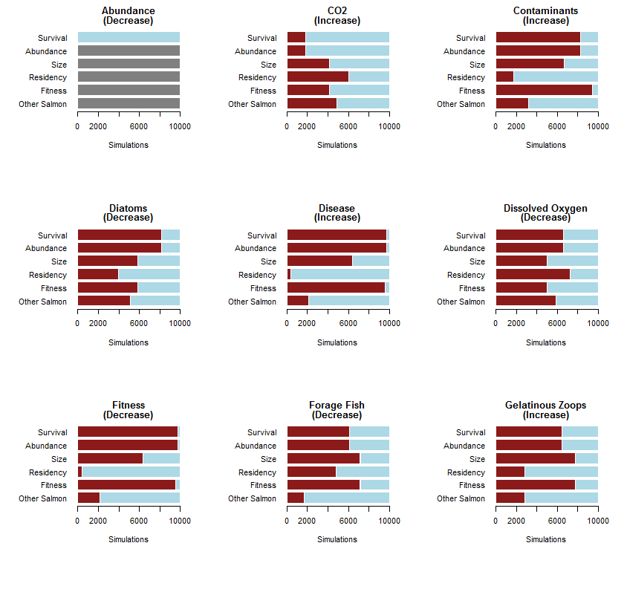

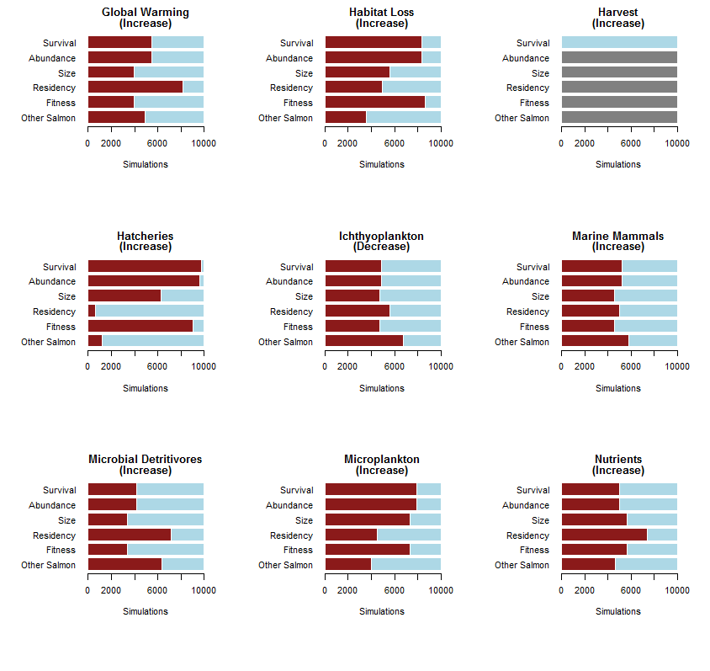

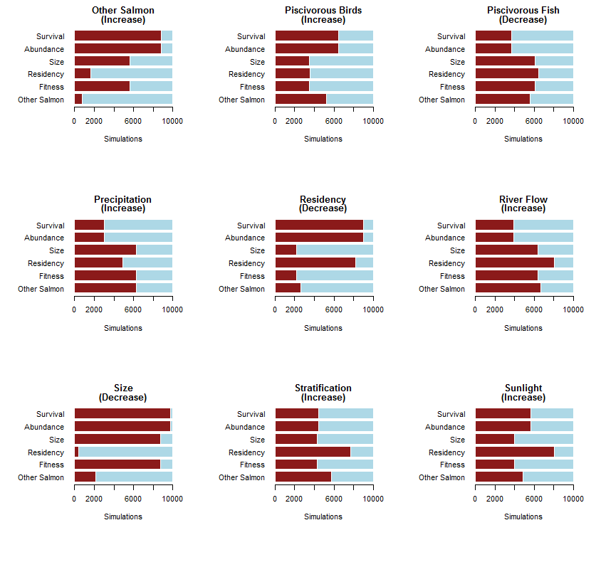

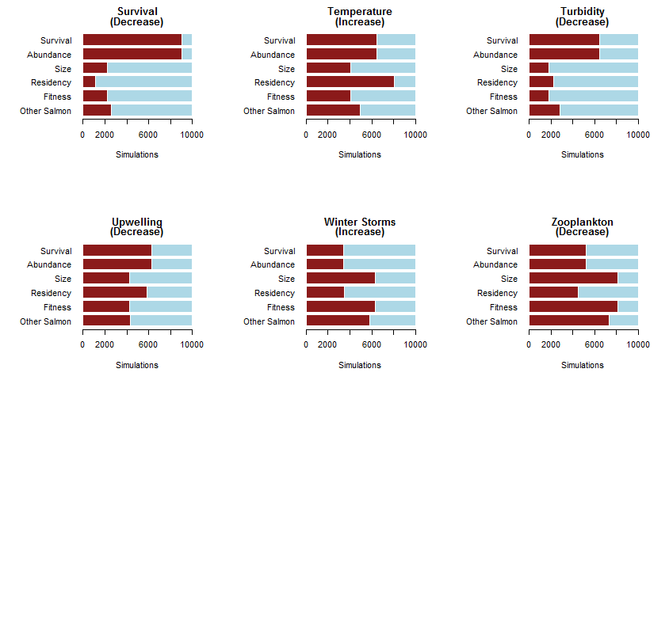

Summary:

* Contaminants and habitat loss have strong negative direct effects
* Hatcheries and disease have a positive effect on other salmon, but very strong negative response on the focal species (Chk, Coho, Stlhd)
* Decreasing dissolved oxygen, temperature, and upwelling have modest negative impacts on all focal salmon traits
* Decreasing turbidity has negative effects on survival and abundance, due to the linkage between turbidity and survival (high turbidity waters provide refuge from visual predators)
* Among food web components, a decrease in zooplankton and a concomitant increase in micropankton are negative; while an increase in piscivorous birds means decreased survival and abundance in the focal salmon and Other Salmon
* An increase in Other Salmon is very negative

|  |  |  |  |  |  |
| --- | --- | --- | --- | --- | --- |
| **South Sound** | Perturbation | **Hood Canal** | Perturbation | **Central Basin** | Perturbation |
| Gel. Zooplank. | ↑ | Stratification | ↑ | Diatoms | ↓ |
| Nutrients | ↑ | Dissolved Oxygen | ↓ | Gel. Zooplank. | ↑ |
| Forage Fish | ↓ | Turbidity | ↑ | Forage Fish | ↓ |
| Contaminants | ↑ |  |  | Habitat Loss | ↑ |
| Hatcheries | ↑ |  |  | Contaminants | ↑ |

Revised scenarios for model runs:

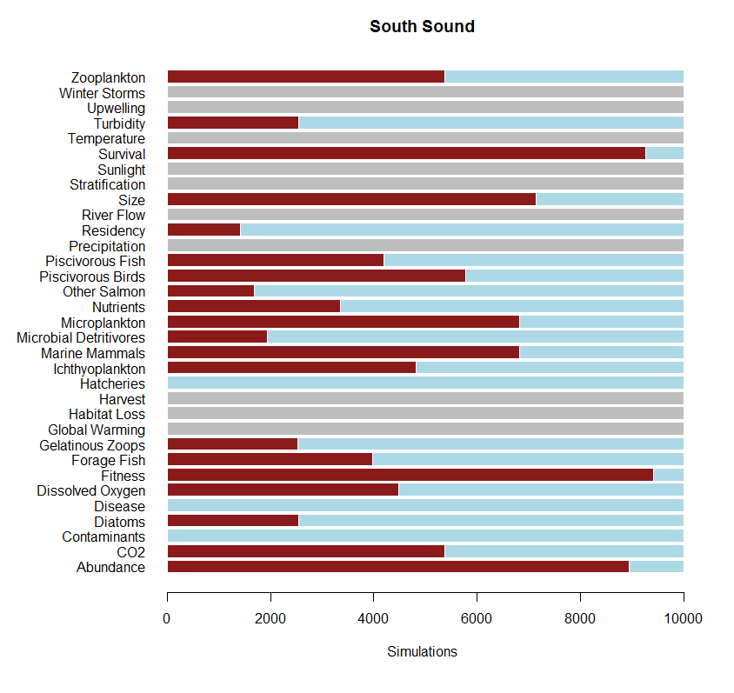

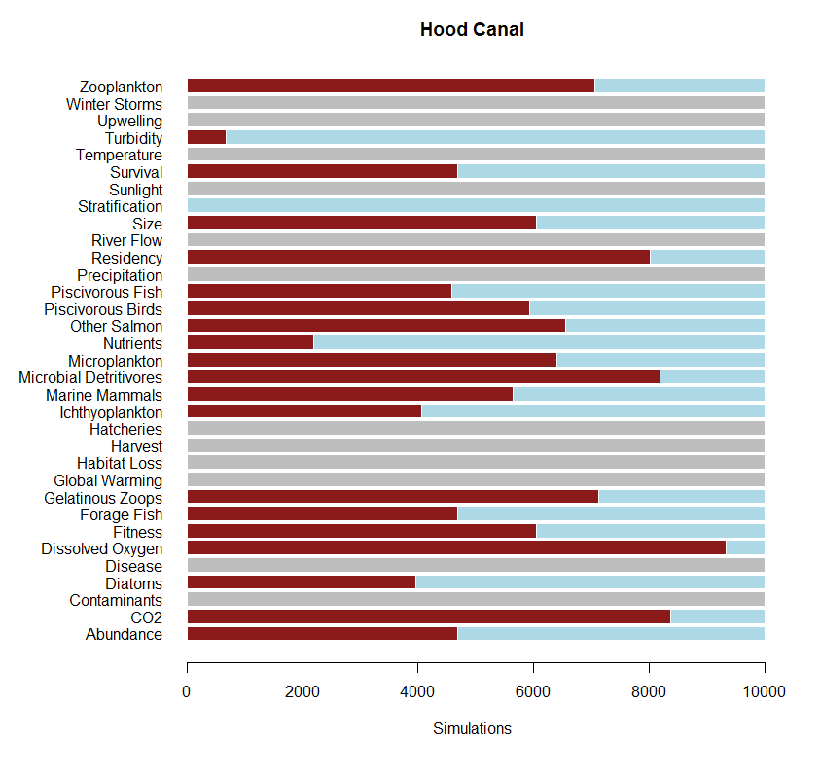

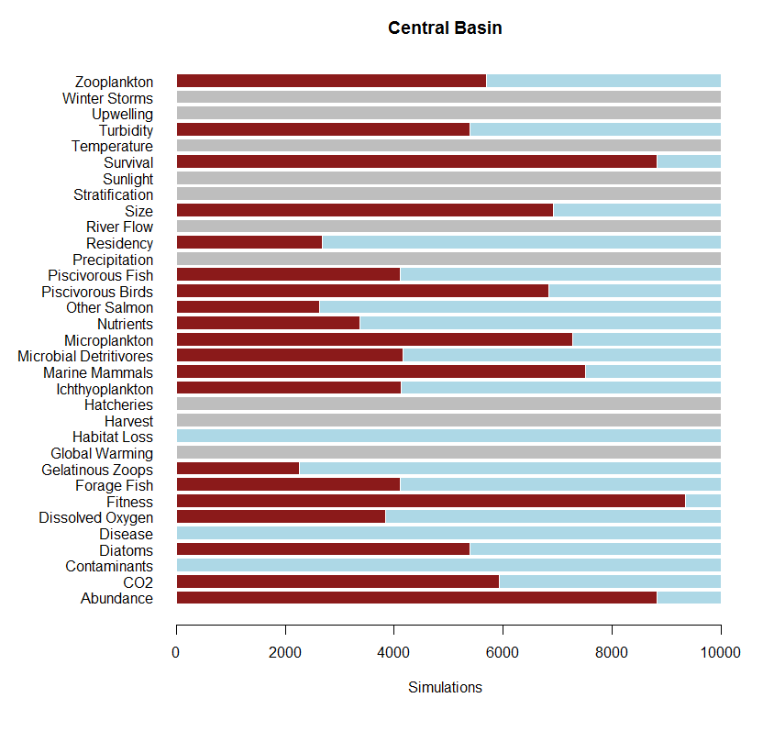

Using a qualitative model to explore the relative impacts of diverse drivers in declining marine survival in Pacific Salmon

# Introduction

In recent years, attention has turned to early marine life-history stages in Pacific Salmon in an effort to understand population declines and failure to rebound given myriad conservation and restoration efforts. In Chinook, Coho, and Steelhead salmon, declines in survival have been evidenced within Puget Sound, WA USA and the Strait of Georgia, Canada that have not been seen in coastal populations (Ruff et al. XXXX, Zimmerman et al. 2015, Kendall et al. XXXX, Johannessen and McCarter 2010).

One tool for evaluating the relative influence of ecosystem components is through the use of Qualitative Network Models (Raymond et al. 2011, Melbourne-Thomas et al. 2012). In fact, researchers have used similar approaches for evaluating ecosystem response to ocean acidification in shellfish management (Reum et al. 2015), the impacts of eutrophication and species management within a foodweb (Carey et al 2013), and for discerning the impact of management actions for species recovery (Harvey et al. XXXX) in the Pacific Northwest. Qualitative Network Analysis (QNA) is an important conceptual tool for discerning relative impacts of ecosystem components. Here we apply this technique to evaluate a suite of potential drivers thought to be contributing to increased early marine mortality in a suite of Pacific Salmon.

# Methods

Our analysis had three main steps: 1.) Construct a conceptual model showing positive, negative, and neutral relationships; 2.) Generate a pool of simulated models, with random weights applied to each model linkage; and 3.) Invoke one or more perturbations and determine the model response. We describe these steps in detail below.

To construct our conceptual model of the Salish Sea system, we gathered experts and literature on ecosystem components and iteratively developed a working model. We began by developing a Kaje matrix (Kaje 1999) listing over 40 possible drivers and the relationships among them. These drivers were drawn from hypothesis about the Salish Sea ecosystem and the decline of Pacific salmon within the system (Salish Sea Marine Survival Project hypotheses, http://marinesurvivalproject.com/wp-content/uploads/Comprehensive-list-of-hypotheses1.pdf). From the Kaje matrix, we developed a diagram using the directed graphing software, Dia (v.0.97.2). This digraph served as the foundation for our qualitative modeling.

While the focus of the modeling effort was on survival of the focal salmon species (Chinook, Coho, and Steelhead), we included salmon life history traits within the conceptual model to specifically evaluate impacts to traits such as size, fitness, etc. The inclusion of model compartments that are not biomass pools highlights the flexibility of qualitative models. While the emphasis was in representing the most direct impacts to this assemblage, we recognize that many of the model components (e.g. temperature) could potentially have direct connections to other model components; we have included these where indirect interactions were important for understanding implications for salmon. As with any model, ours is a reductionist view of the ecosystem and omission of some connections and ecosystem components was necessary to emerge with a conceptual diagram that was both representative and practical. Our final conceptual model had 34 compartments, including climate/atmospheric, oceanographic, food web, and anthropogenic drivers (Fig. 1).

We used the *QPress* package for Qualitative Network Analysis (Raymond et al. XXXX) in R (R Core Team 2016) to interpret the conceptual digraph. Given a network model, this package provides routines for evaluating the impact of a press perturbation to the system through simulation. We simulated the network ~120,000 times to result in 10,000 stable simulated networks. For each simulation a weight (drawn from a random uniform distribution, 0-1) was assigned to each pathway (edge) and if the resulting model with the assigned weights was stable, the model was accepted.

To test a suite of hypotheses concerning drivers to the Salish Sea ecosystem, we developed *a prior*i perturbations to invoke. Once we had a pool of stable models, we could then invoke an increase/decrease to any model compartment and observe the outcomes for any selected compartment or a group of more than one. For example, we are interested in foodweb effects, so decreased the forage fish compartment and observed the impacts to other model boxes, such as salmon size or survival.

We present summaries of preliminary data here (Fig. 2-X).

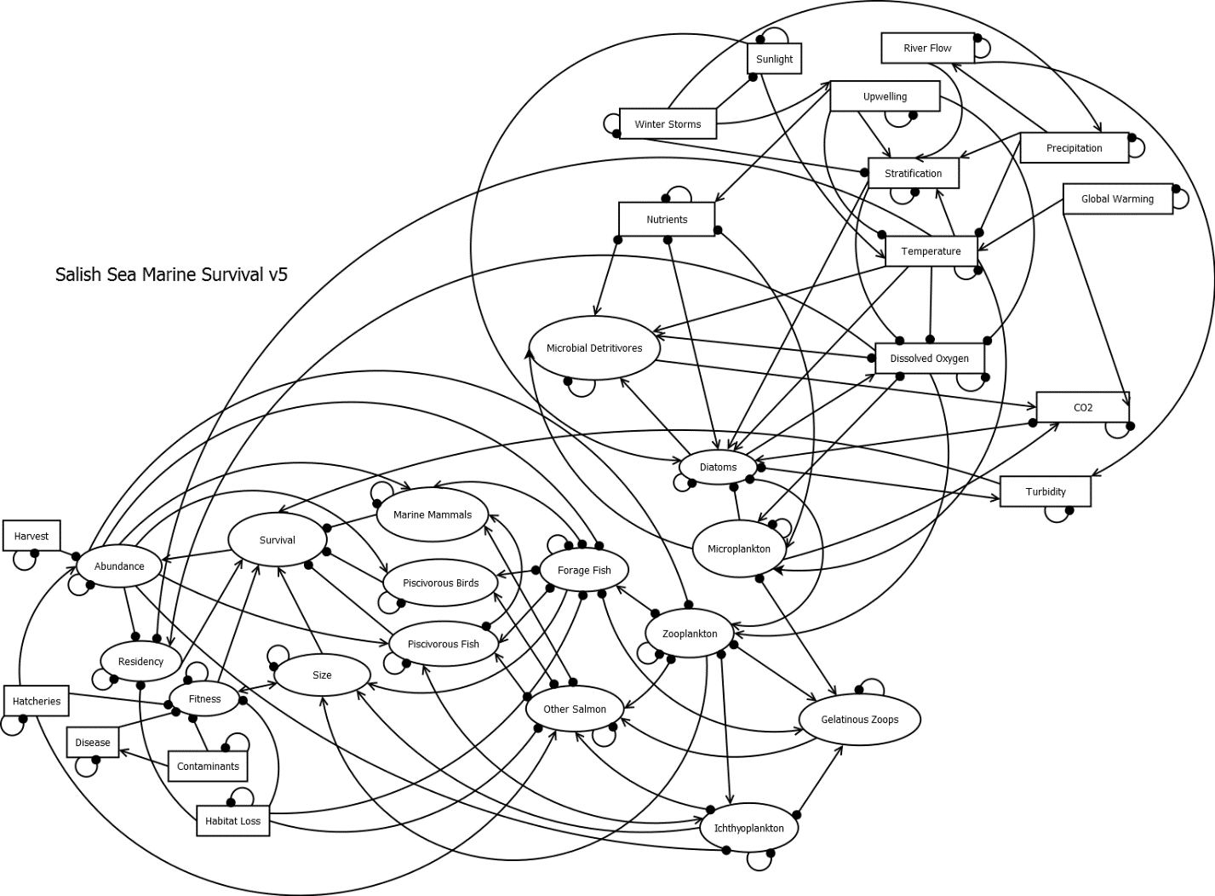

Figure 1. Conceptual directed diagram (digraph) of the Salish Sea in relation to survival of salmon. Model compartments (ovals or rectangles) represent biomass pools, ecosystem drivers, and traits on interest. Lines with arrows show positive relationships; lines with filled circles show negative relationships. Small negative loops on model compartments represent self-limiting functions.

# Literature Cited

Carey, M.P., P.S. Levin, H. Townsend, T.J. Minello, G.R. Sutton, T.B. Francis, C.J. Harvey, J.E. Toft, K,K. Arkema, J.L. Burke, C. Kim, A.D. Guerry, M. Plummer, G. Spiridonov, and M. Ruckelshaus. 2014. Characterizing coastal foodwebs with qualitative links to bridge the gap between the theory and the practice of ecosystem-based management. *ICES J Mar Sci* 71: 713−724.

Harvey, C.J., J.C.P. Reum, M.R. Poe, G.D. Williams, S.J. Kim. *In Press*. Using conceptual models and qualitative network models to advance integrative assessments of marine ecosystems. *Coastal Management*.

Kaje, J. 1999. Kaje System: A conceptual modeling tool for interdisciplinary research. Univ. of Washington Applied Physics Lab.

Melbourne-Thomas, J., S. Wotherspoon, B. Raymond, and A. Constable. 2012. Comprehensive evaluation of model uncertainty in qualitative network analyses. *Ecological Monographs*, 82(4): 505–519.

R Core Team. 2016. R: A language and environment for statistical computing. R Foundation for Statistical Computing, Vienna. www.r-project.org

Raymond, B., J. McInnes, J.M. Dambacher, S. Way, and D.M. Bergstrom. 2011 Qualitative modelling of invasive species eradication on subantarctic Macquarie Island. *Journal of Applied Ecology* 48: 181–191.

Raymond, B, J. Melbourne-Thomas, S. Wotherspoon. 2012. QPress: Qualitative Network Analysis.

Reum, J.C.P., B.E. Ferriss, P.S McDonald, D.M. Farrell, C.J. Harvey, T. Klinger, and P.S. Levin. 2015. Evaluating community impacts of ocean acidification using qualitative network models. *Marine Ecology Progress Series* 536: 11-24.